2/21/18

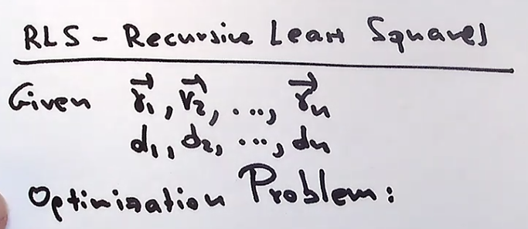

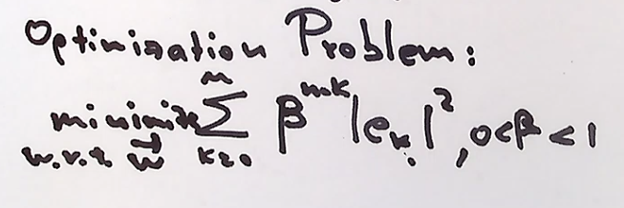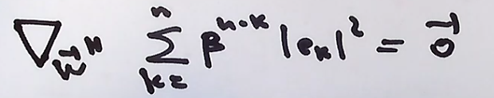

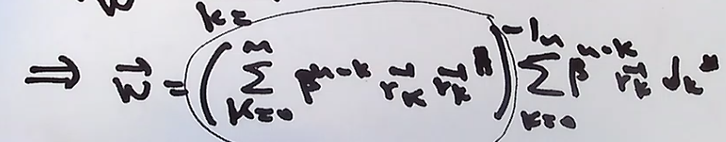

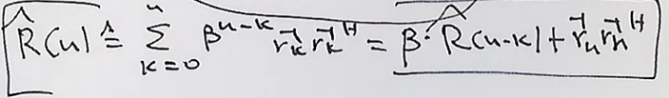

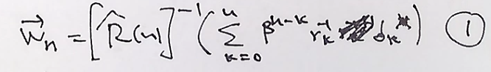

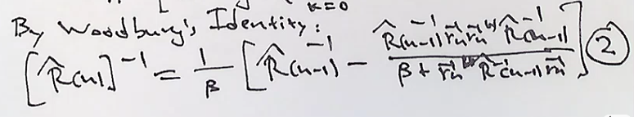

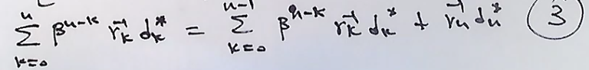

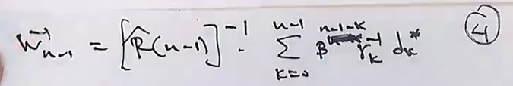

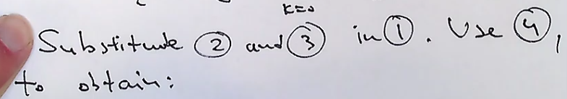

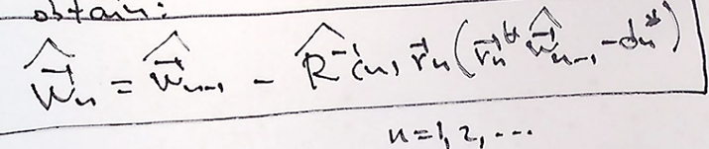

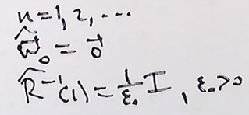

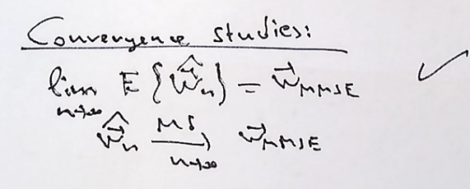

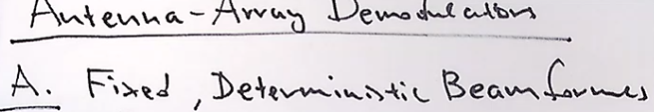

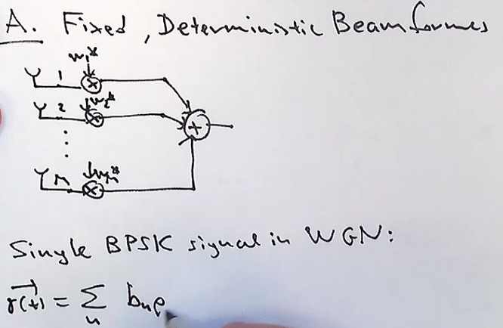

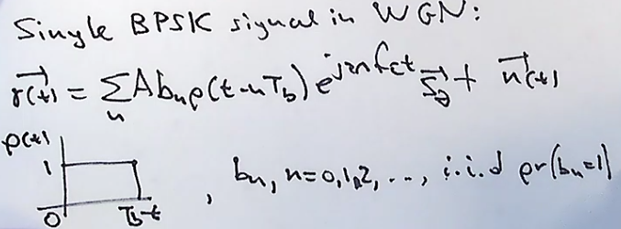

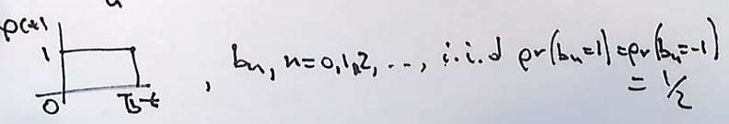

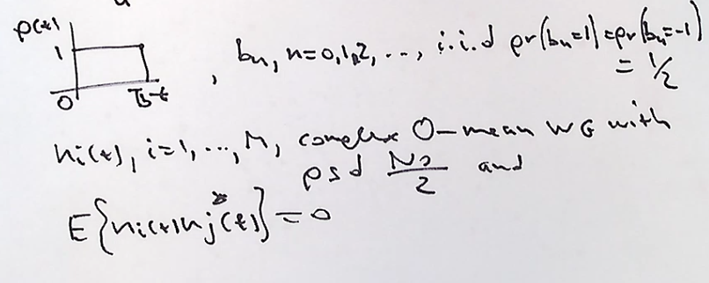

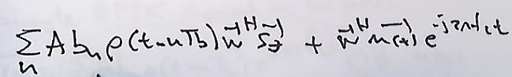

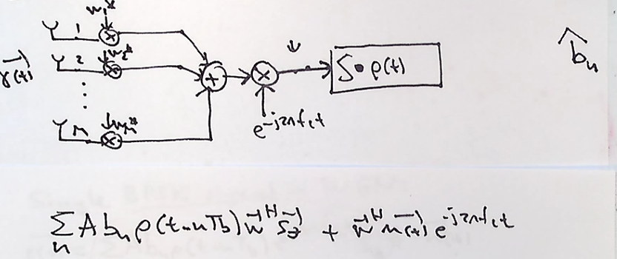

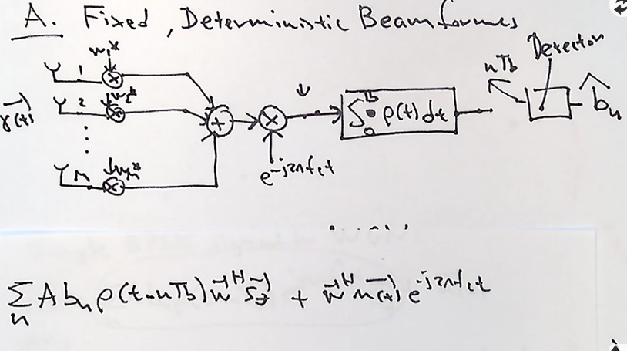

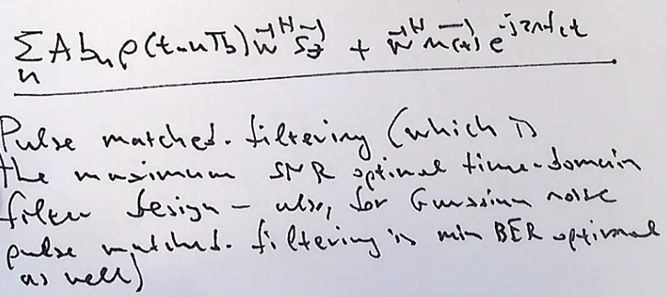

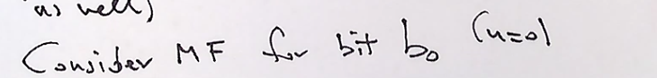

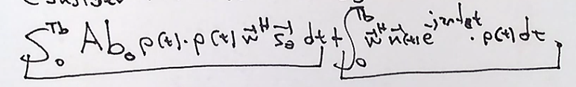

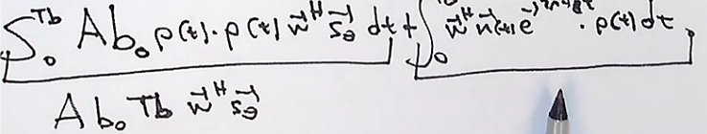

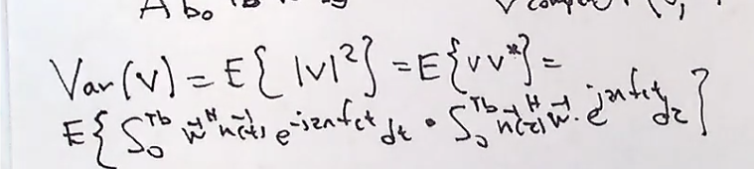

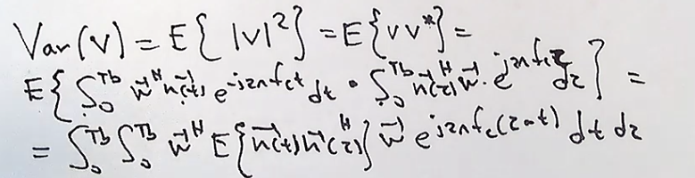

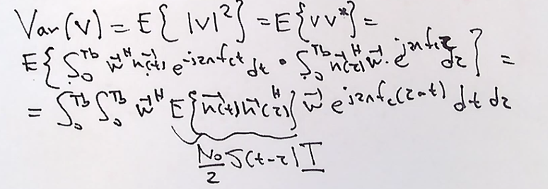

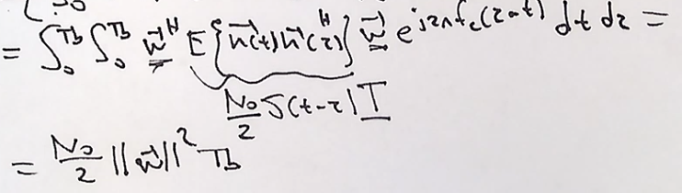

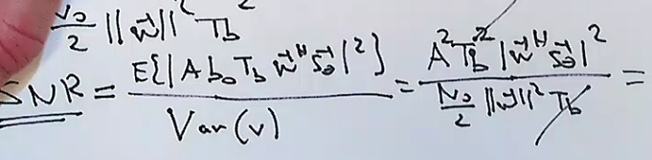

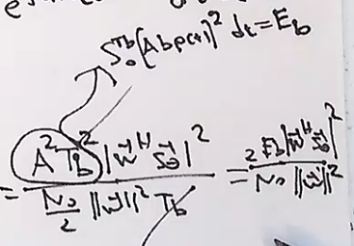

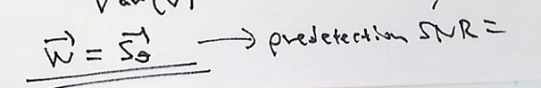

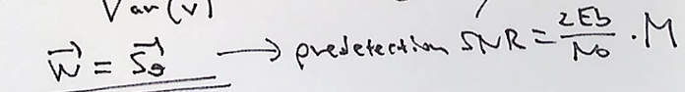

2/23/2018

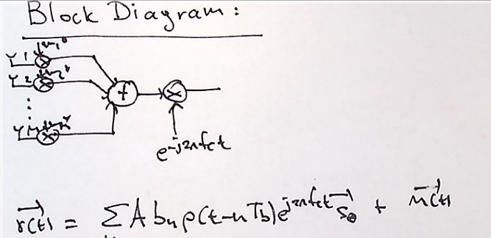

We need a time domain processor that creates pulses. We will use a pulse match filter that integrates from 0 to Tb, and multiplying it by the signal. A switch will trigger at a rate of 1/Tb. Eventually a good decision for bits will be achieved. At some minimum Bit Error Rate. Or an optimum detector for BER

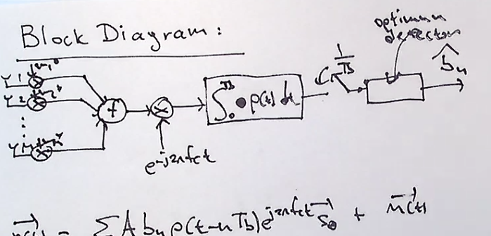

What feeds the optimum detector is due to the input signal. The n(t) is beamformed , carry modulated then its pulse match filtered. We proved it becomes a gaussian random variable with mean of 0 and a variance of as a function of the weight vector w.

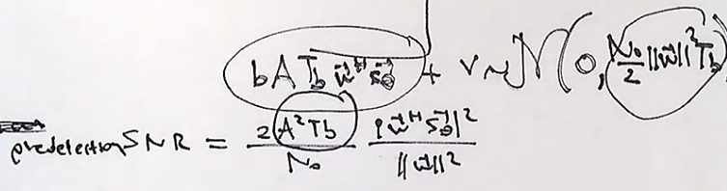

Optimum detector has an SNR input of the predictor SNR show above.

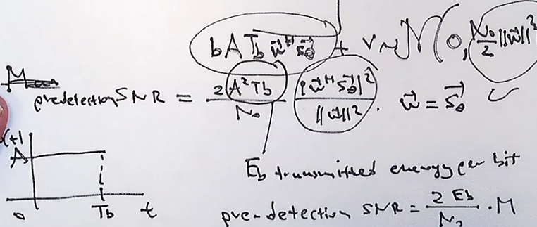

We can see that if we properly set the weight vector to stheta we get a predetector snr with a gain of M.

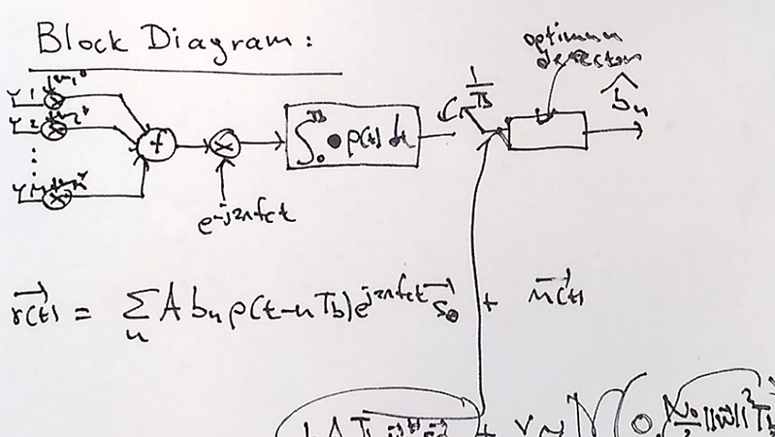

What if we want to adjust the pulse signal. How do we build this optimum detector? Analog hardware has to be specific to the Pt we are using.

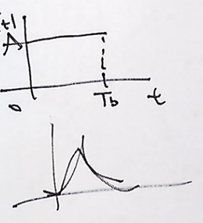

Lets focus on the time domain processor :

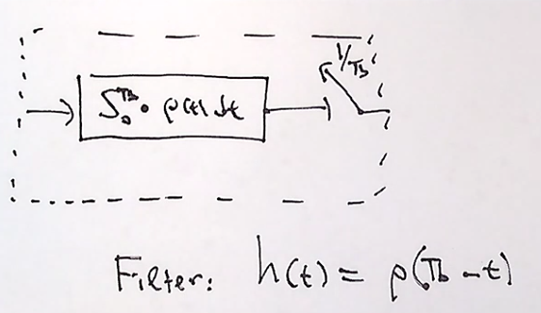

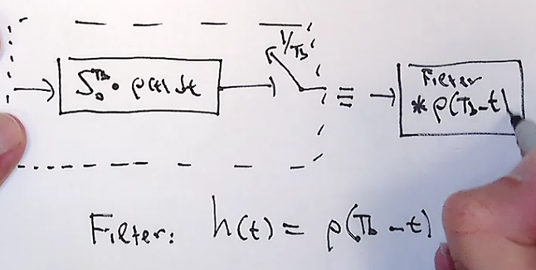

Instead of using a pulse match filter with time integral a convolution of the pulses can be equivelant. Consider the following pulse:

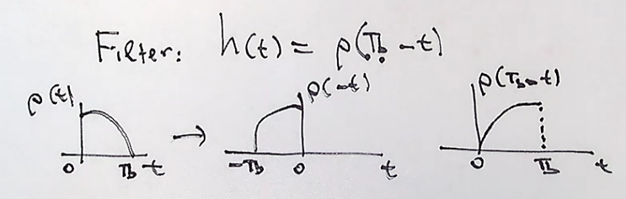

Notice that the output of the pulse matched filter integrator would have the same integration as the outut of the convolution filter.

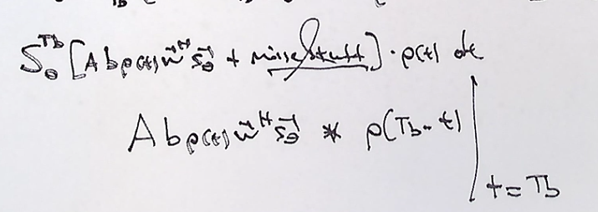

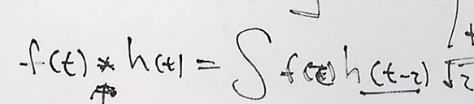

Convolutions can be implemented really quickly with FFT’s. But we can get even cheaper if wee use a low pass filter. The approximation to the matched filter and the convolution filter can be done with a low pass filter. This is called fractionally spaced equalizer and “digital receiver”. The fourier transfer of a pulse signal looks like :

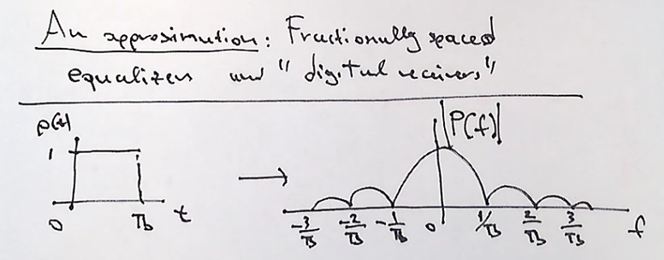

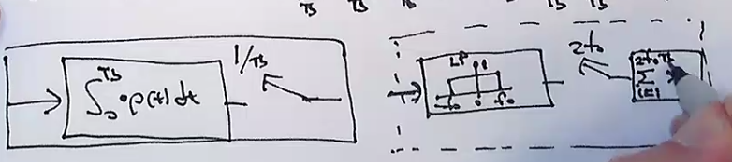

Look at the output of a low pass filter with cut off frequency, f0;

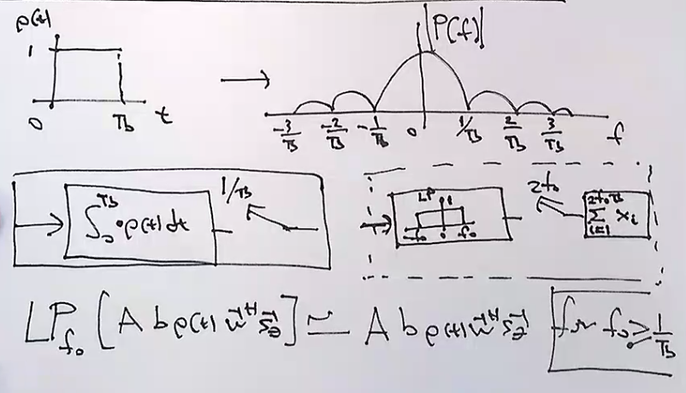

We can also analyze what happens to the noise components using a low pass filter approximation. We would need to calculate the autocorrelation to the input of the low pass filter.

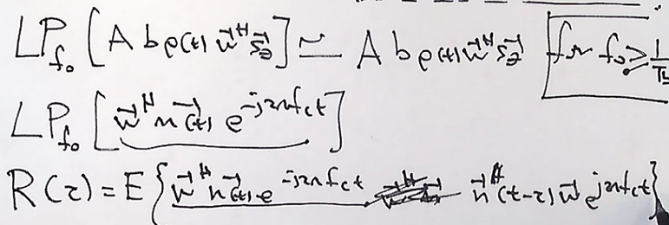

After simplifying the autocorrelation matrix of the input. We need to move the random parts within the expectation and move the deterministic components outside the expectation.

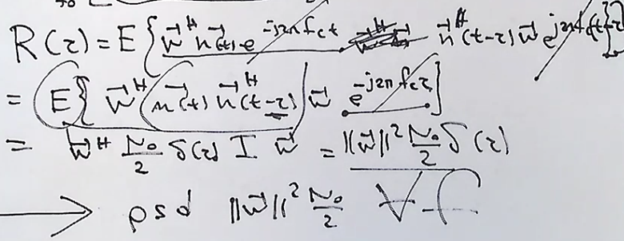

Here we see that the power spectral density of the low pass filter noise process is going to be the power of the weight vector . for all frequency from +/- f0;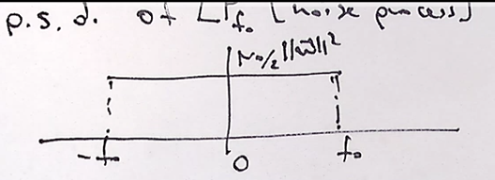

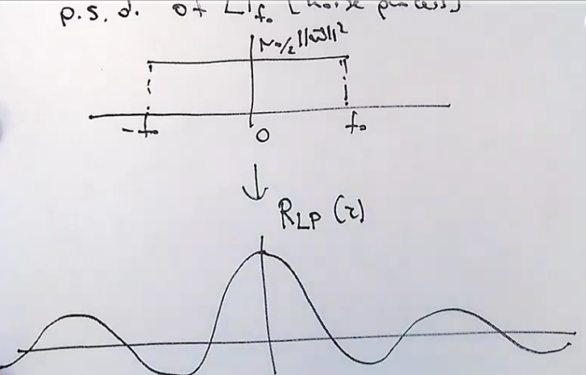

The autocorrelation function can be found with the invere fourrier transform

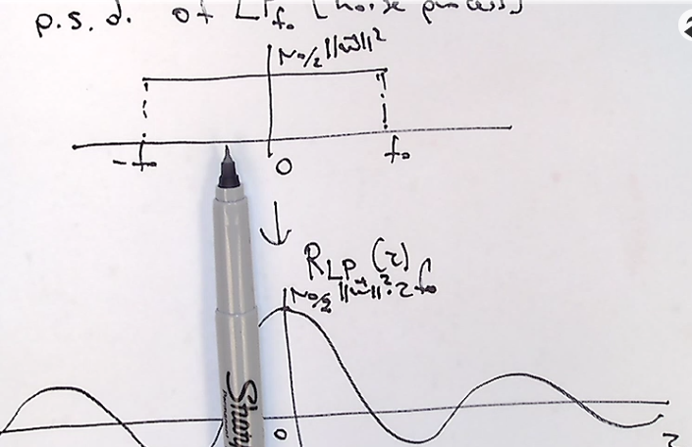

We can simplify the intersect :

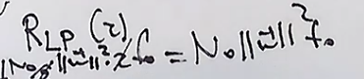

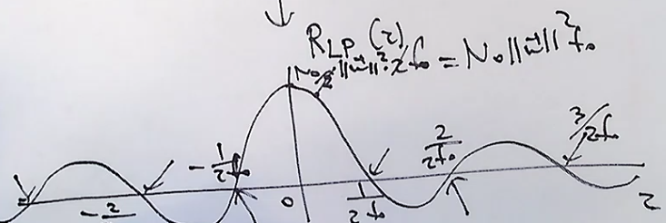

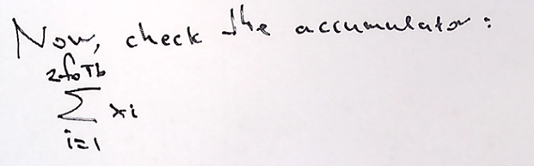

We know that our signal with lowpass filter comes in with no loss. And now we need to accumulate the samples and do it for the Nyquist sampling rate. P for us is 1. The total is 2*f0 times the input signal. Butwe also have thesamples from our noise process.

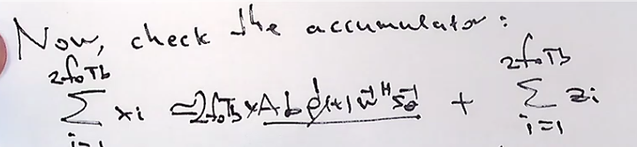

We need to find the noise samples and understand how to accumulate them too.

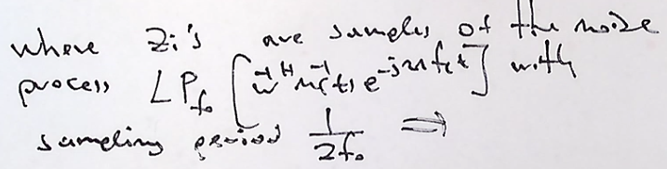

The mean and variance is shown below for each of the noise samples.

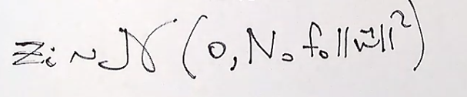

When you sample at multiples of 2f0 then the autocorrelation of the noise is 0, meaning the noise variable is independent at that point.

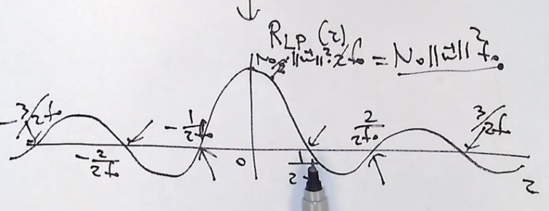

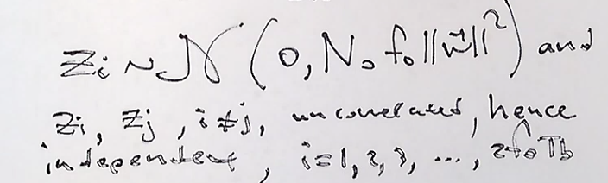

So the SNR at the output of the accumulator is : the expected signal contribution squared over the variance of the noise.

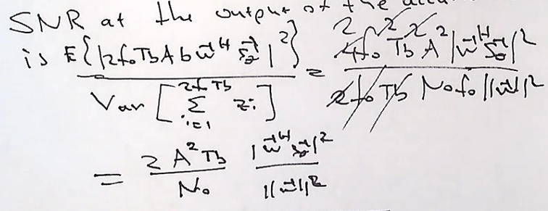

This is now the same as what we got from the original Ideal SNR result we looked at originally.

2/28/2018

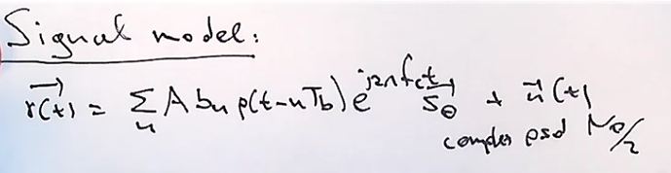

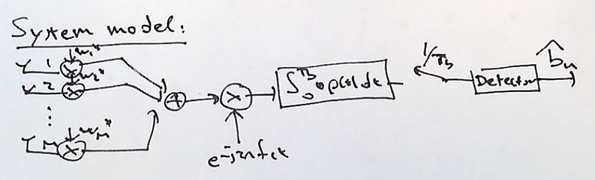

There are two ways to implement the math filtering. One is convolution and the other is with a low pass filter.

Lets assume an energy pulse with the following :

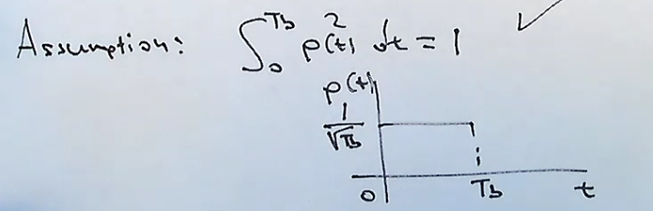

Lets look at the input to the detector:

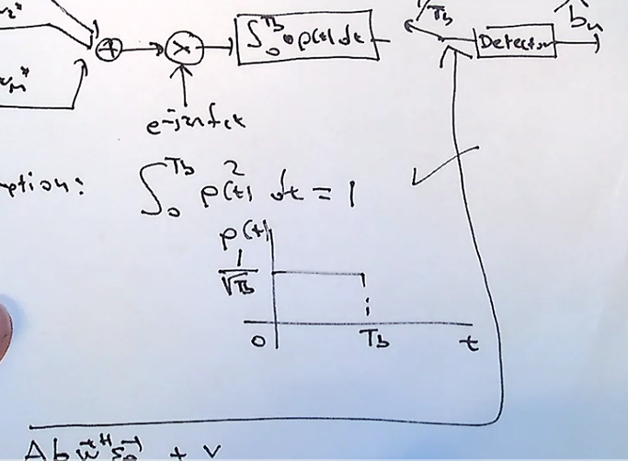

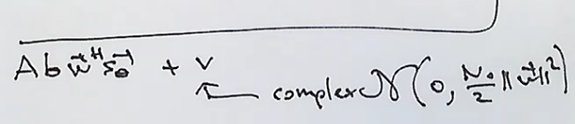

We can re-write this input signal as the following :

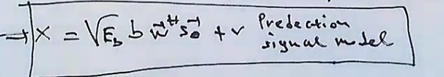

The objective Is now to design the optimal detector for the previous signal value.

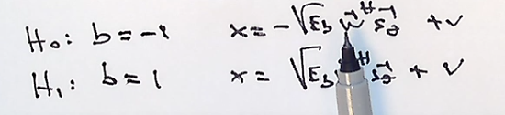

PDF for each hypothesis

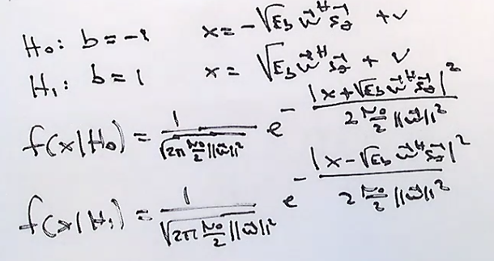

Compare the hypothetical probabilities :

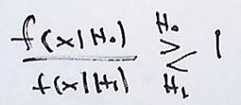

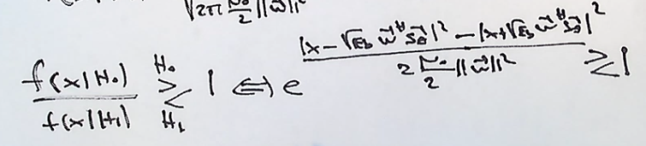

Multiply both sides by Ln when doin the test and now our test looks like this :

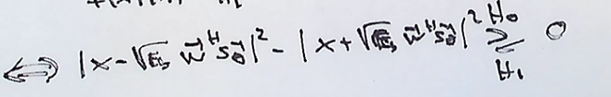

Squared magnitude of a complex number is the mutiplaction of its conjugate :

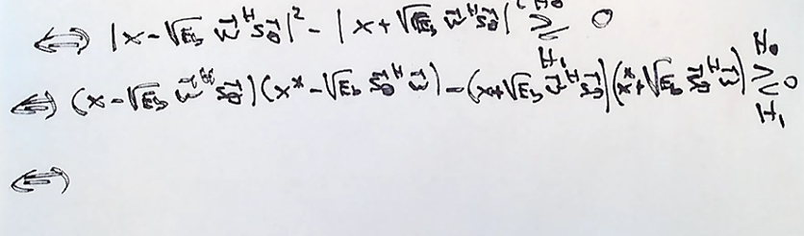

After more algebraic simplifications we get to the following:

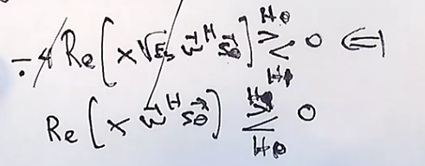

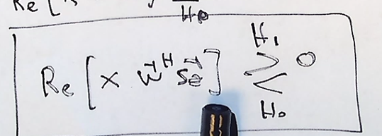

If we set the w to a mvdr, or mf or mmse filter by setting it to scaled stheta makes it real and positive, so we can conclude our test as follows by moving that real part outside of the test. And we can see that the real part of x is what we need to test if its h1 or h0.

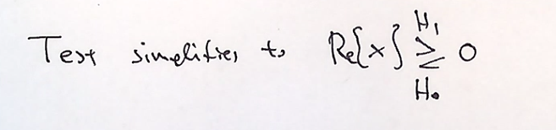

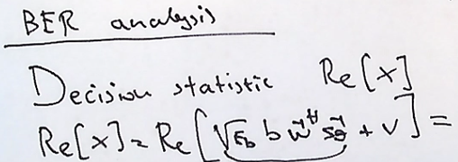

If we have chosen the weight vector to be real

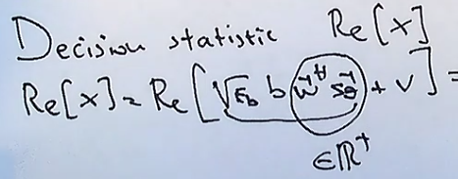

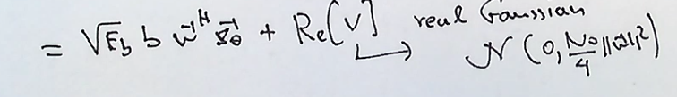

So the apriori of the h0 is equal to the apriori of h1 = ½

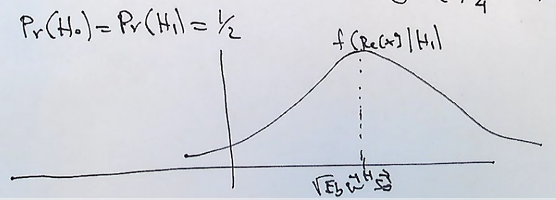

The PDF of H1 is shown above. If we map it for h0 we can something similar, and they intersect at ½

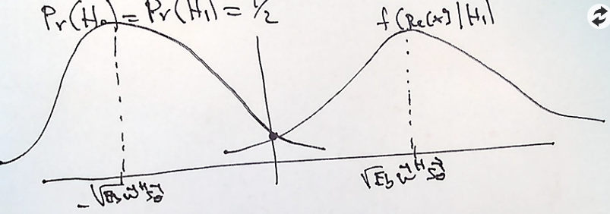

We make an error when the H0 and H1 is true.



We need to use bayes conditional probability theory for joining these probabilities together.

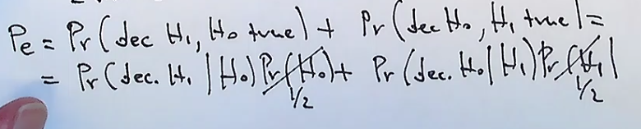

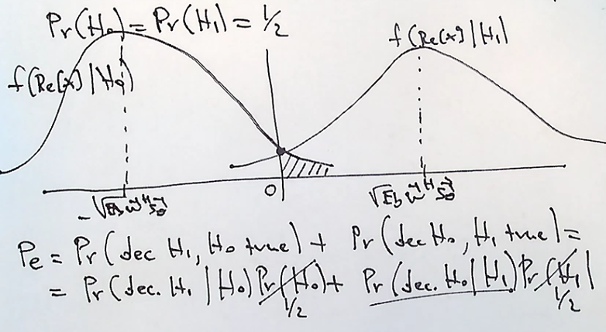

By symmetry the probabilities of error for either are the same :

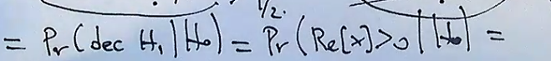

So we can find the integral from 0 to infinity for the PDF to get the value for the probability of error.

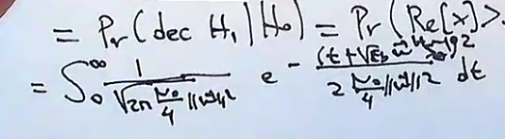

Lets do a change of varitables to solve the integral.

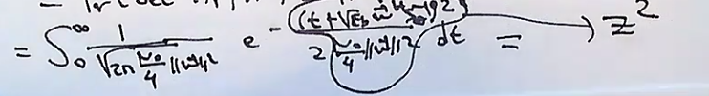

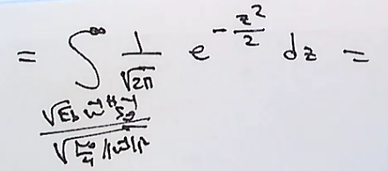

This is similar to a Q function that is defined as :

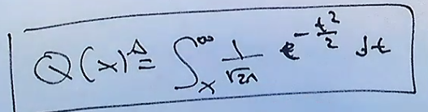

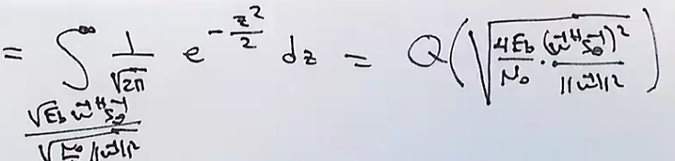

The BER Is made up of two compoments, the SNR of the real noise. Times another term that is maximized for w = stheta. So it becomes M.

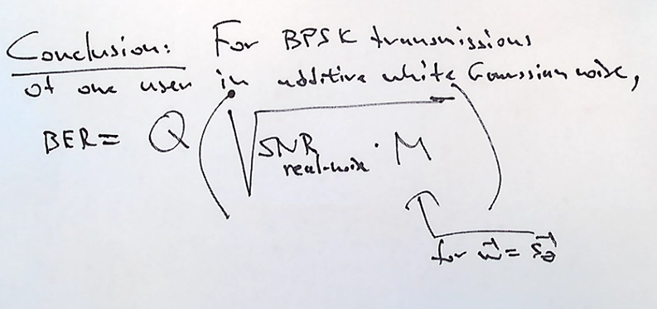

Example a BER of 10^-5 means 1 error out of 10^5

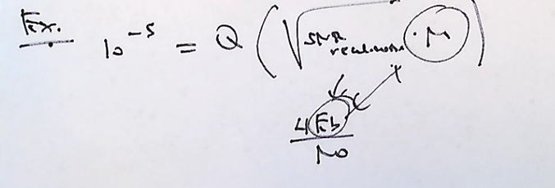

MultiUser communication , same bits, same signal but different angles of arrival.

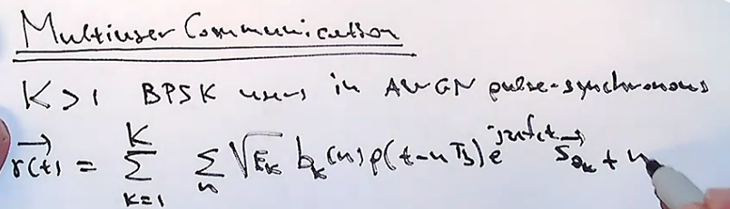

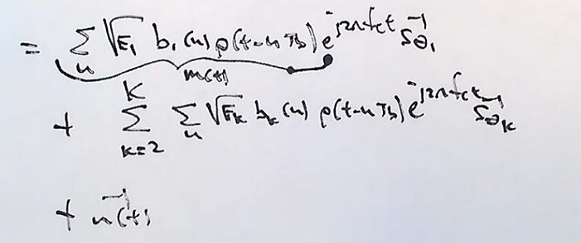

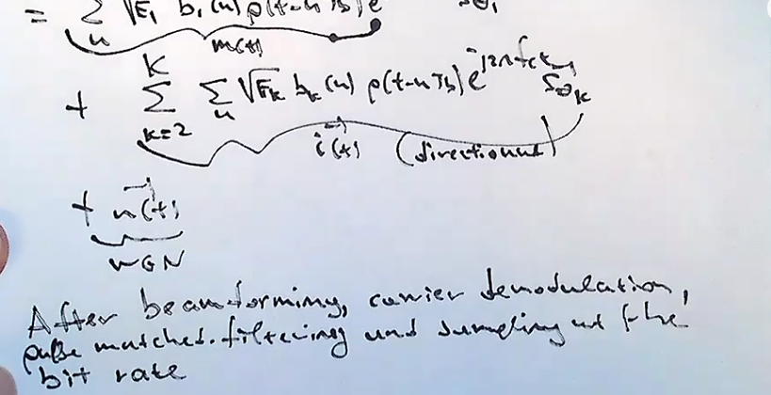

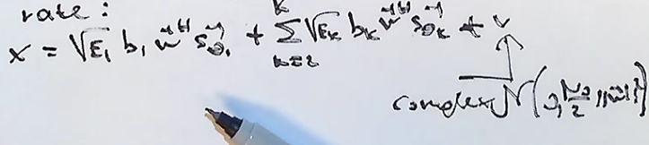



3/14/2018

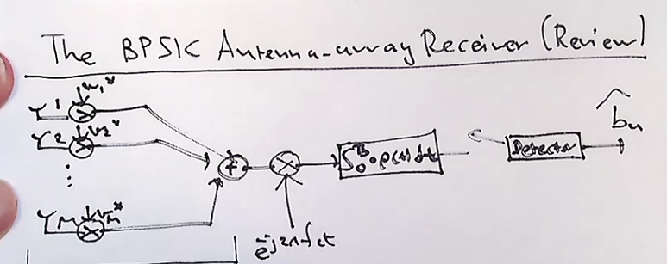

1. Space processor
2. Time Processor
3. And the detector

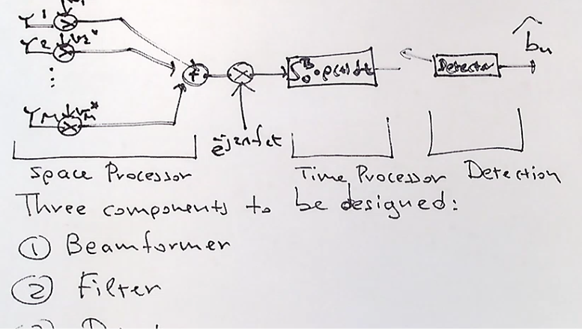

Optimizing each one of these components doesn’t guarantee overall optimization. But for the case of one bpsk user and AWGN if you do max snr beamforming on the space processor (w =s_theta). an

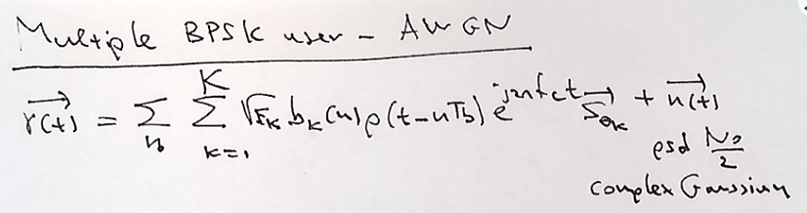

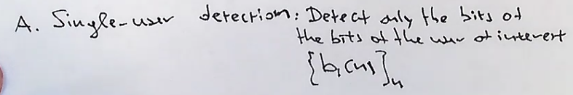

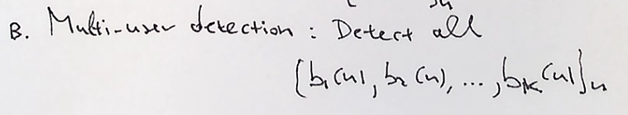

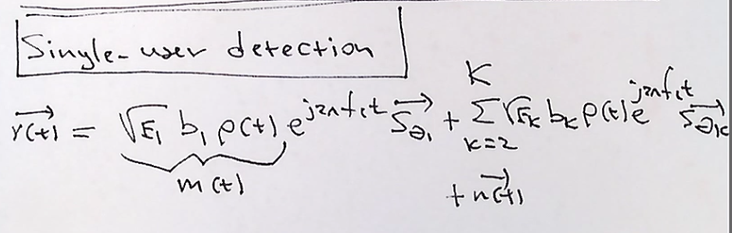

Narrow band assumption says that the fc of the received signal is far from other frequencies.

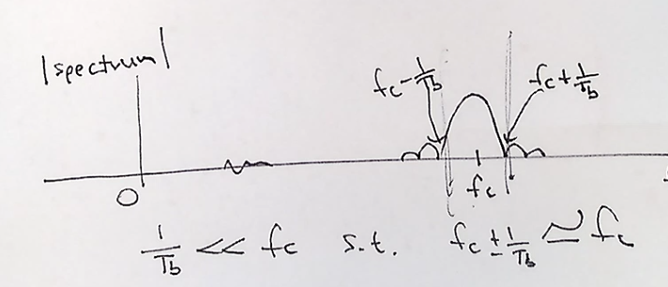

Narrow band assumptions :

Time domain: mt does not change from one antenna element to the other

Frequency domain : fc +/-1 Tb Is very close to Fc

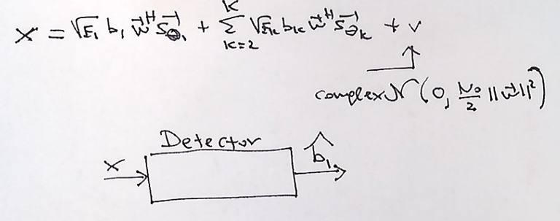

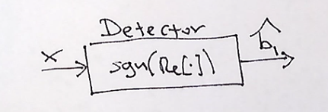

Predict the probability of error with some fixed interefers .

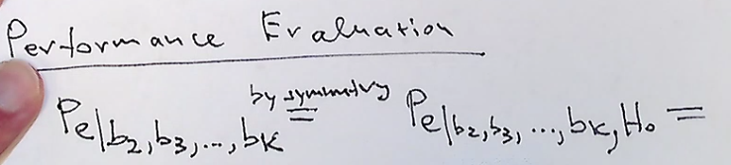

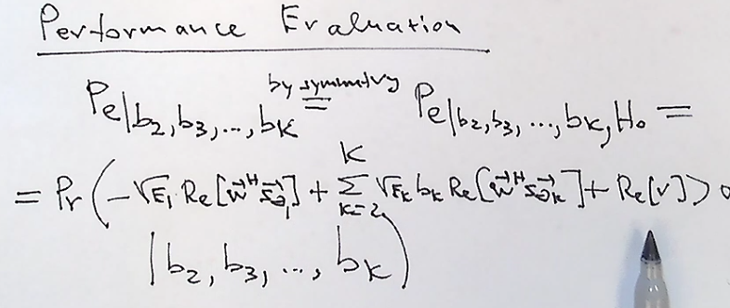

Only look at the random variables in the probability and move fixed values outside :

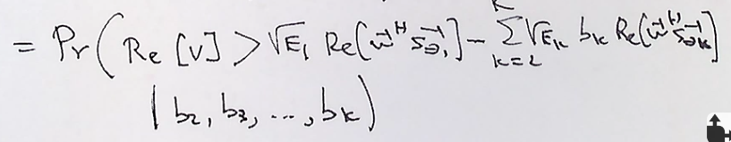

Real part of the complex number has half the variance so its N0/4

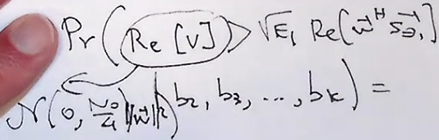

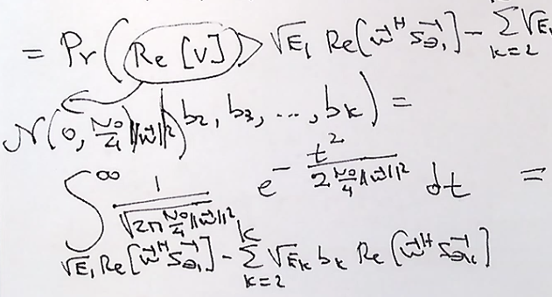

Take exponent and do a change of variables

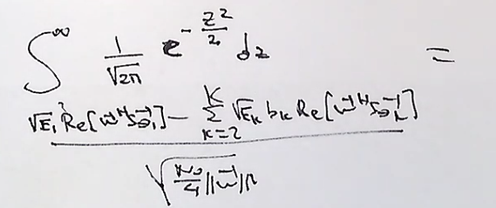

This can now be placed into a defined q function to solve it :

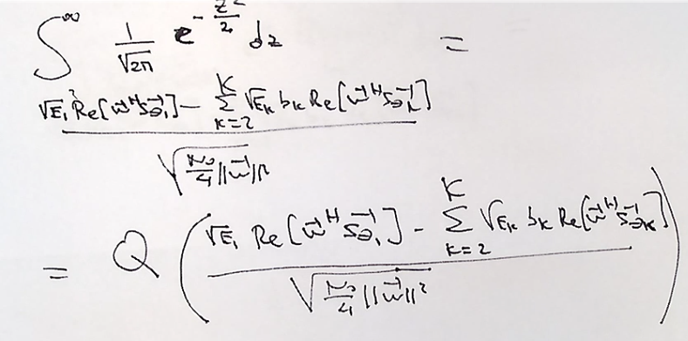

So now thinking about the average of all the other porbaiblites of the other users we can design an expected value for each signal on average and get a probability of error.

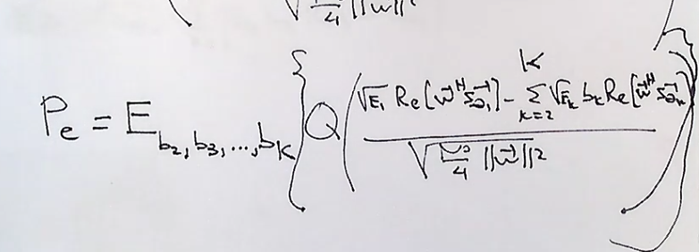

Cost of calculating the probability error of the receiver with other users ?



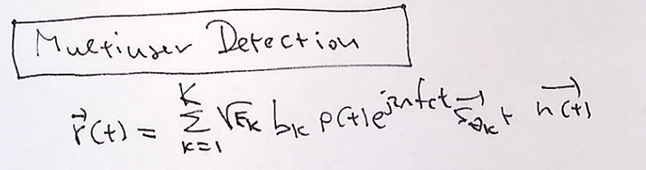

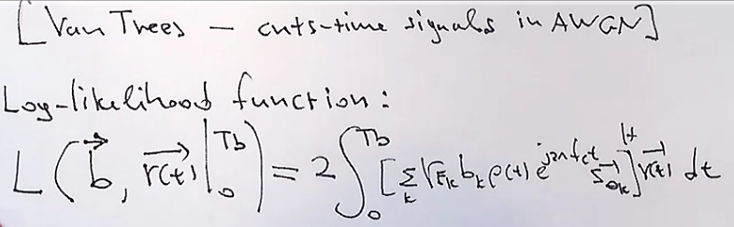

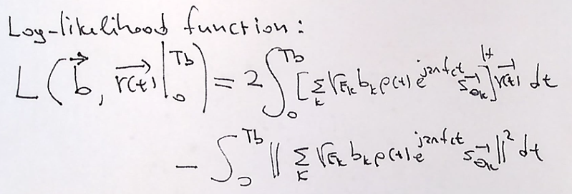

3/16/18

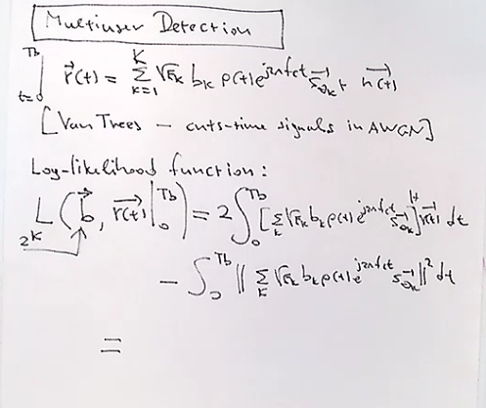

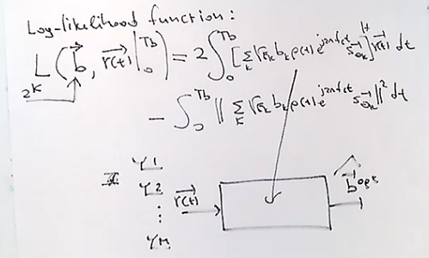

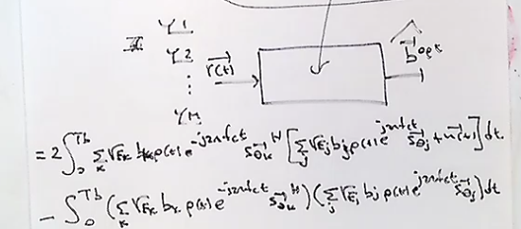

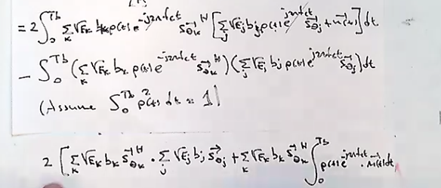

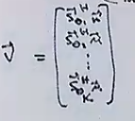

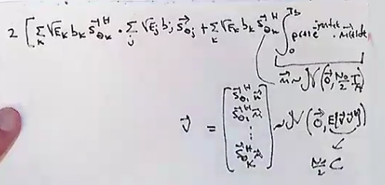

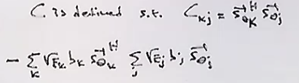

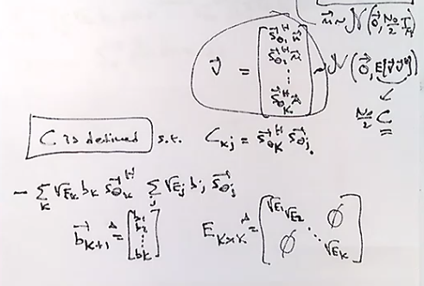

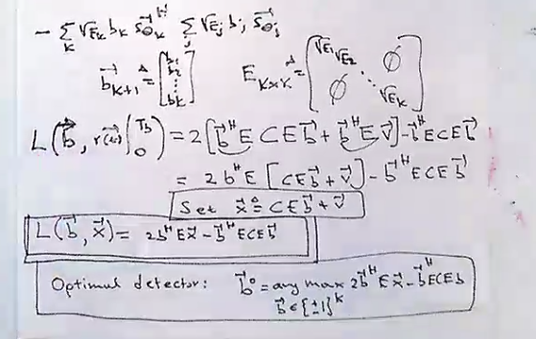

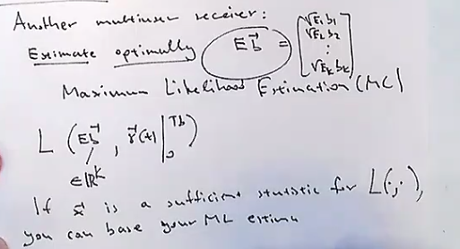

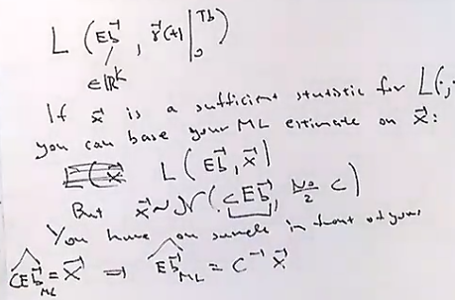

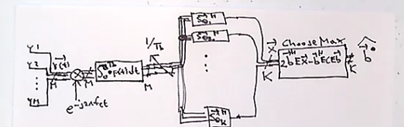

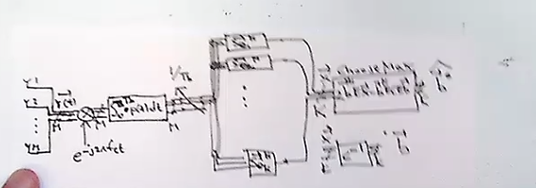

LMS Class

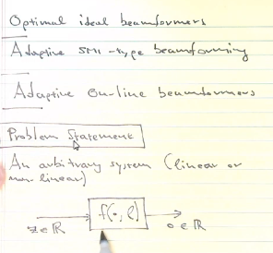

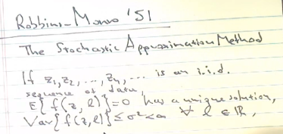

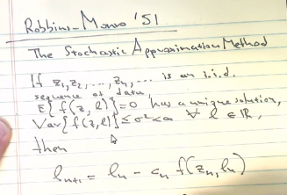

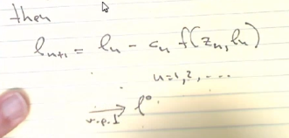

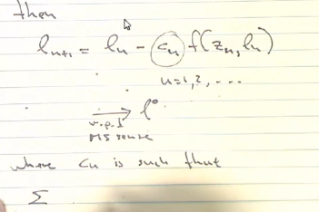

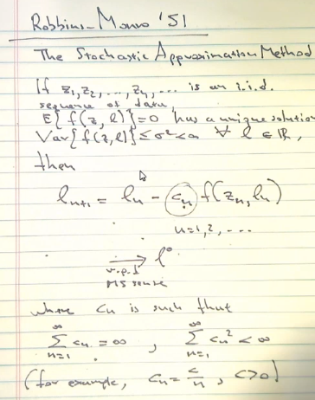

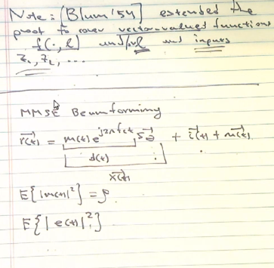

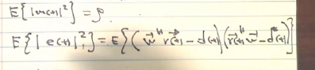

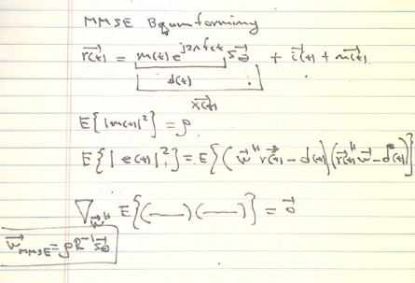

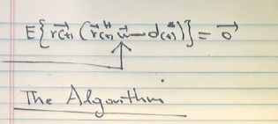

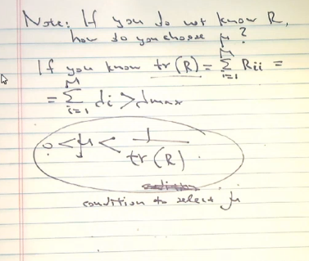

Array response vector

Narrow band assumption

Space domain Nyquist sampling

Ideal beam formers (mvdr, mmse, maxsinr, ml)

Adaptive beamforming SMI (Sample matrix inversion)

Adaptive beamforming type 1,2,3

Adaptive Online beamforming

MLS recurssions (Stochastic Approximations)

Robins Monroe.

Design of antenna recievers

One User AWGN

Optimal : Matched Filter (array response vector)

Multiple Users AWGN

SubOptimal : Matched Filter

Optimal : Decorrelating

Derive , discuss, comment